***PAAREES PERFUMES***

***VERSACE***

***FOR MEN***

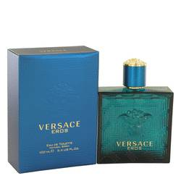

# 

***VERSACE EROS***

## *Description:*

Versace Eros by Versace Cologne. There's nothing wrong with dinner at a fancy place or an expensive piece of jewelry when you are trying to impress someone and win her heart. However, what you need in addition to these louder means of displaying affection is a subtler strategy, something that will make her think of you in the quiet moments before she falls asleep. Introduced in 2012 for men, Versace Eros by Versace combines the aromatic notes of mint, green apple, tonka bean and geranium to create one unforgettable fragrance.